







UID /home/

ReadySetResource.com

# Creds

# 7.1 - Home

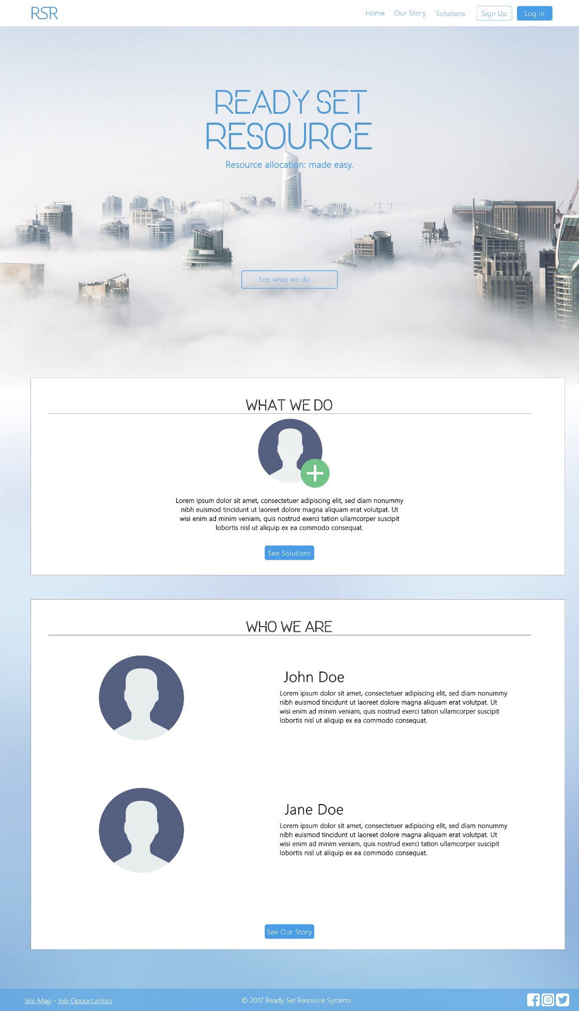

Input Permissible: None

Error Messages: None

# 7.2 - Our Story

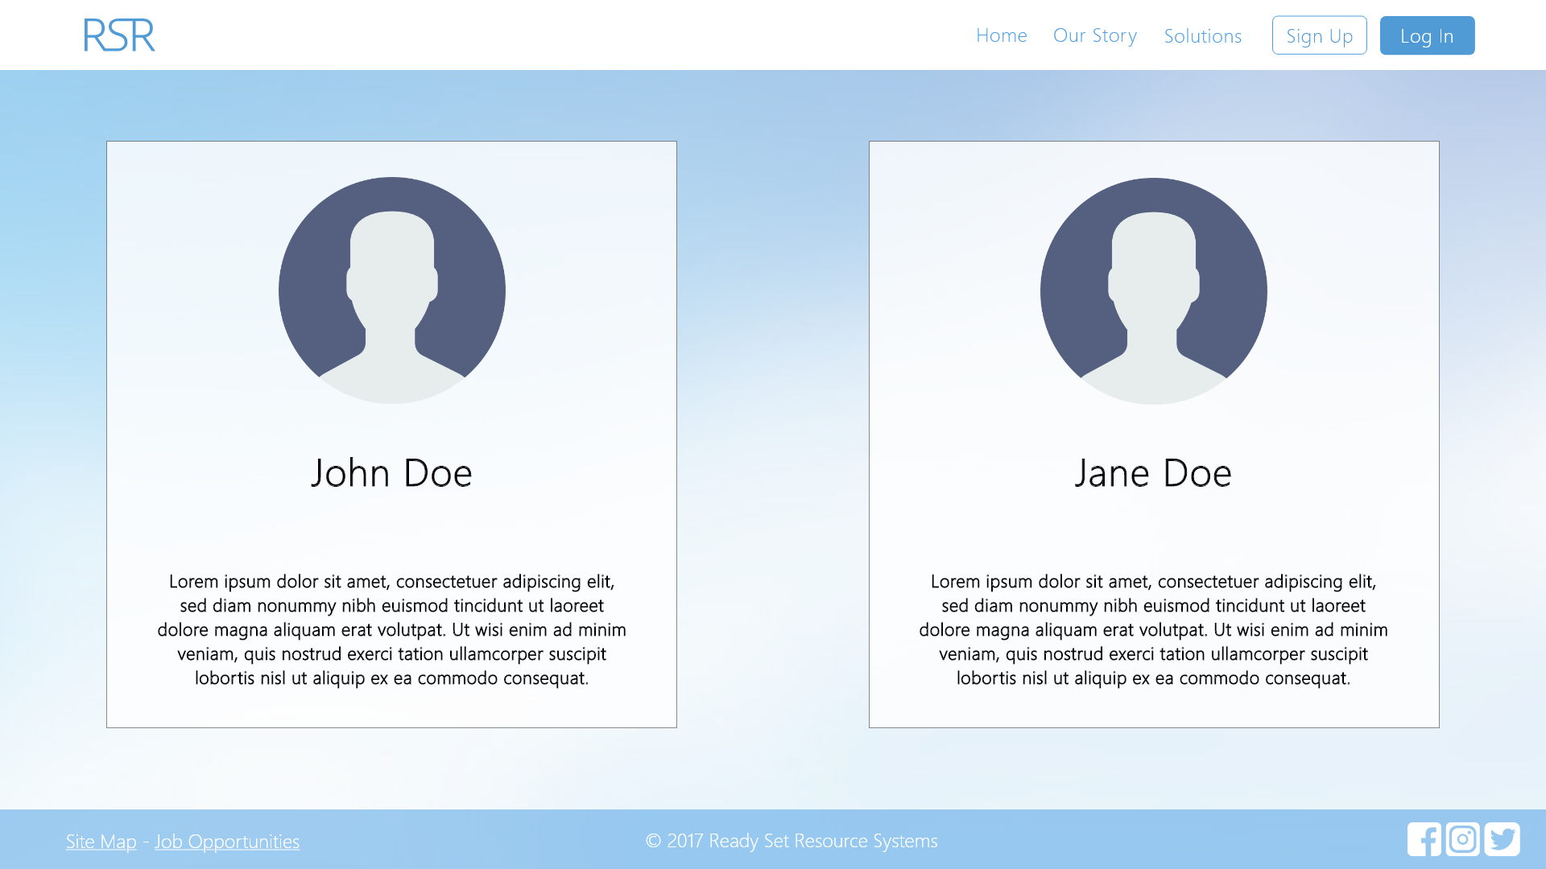

# 7.3 - Solutions

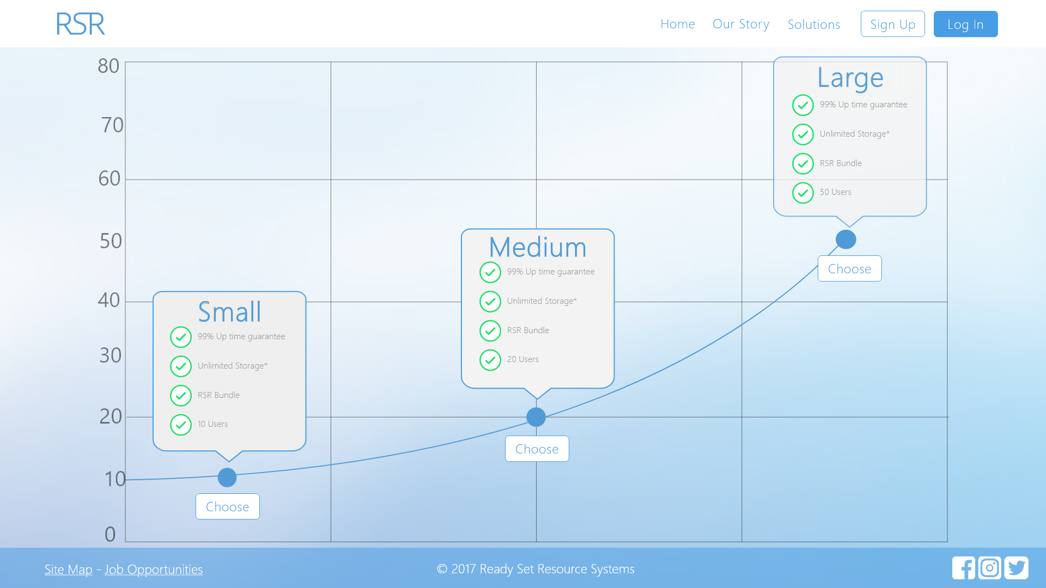

# 7.4 - Log In

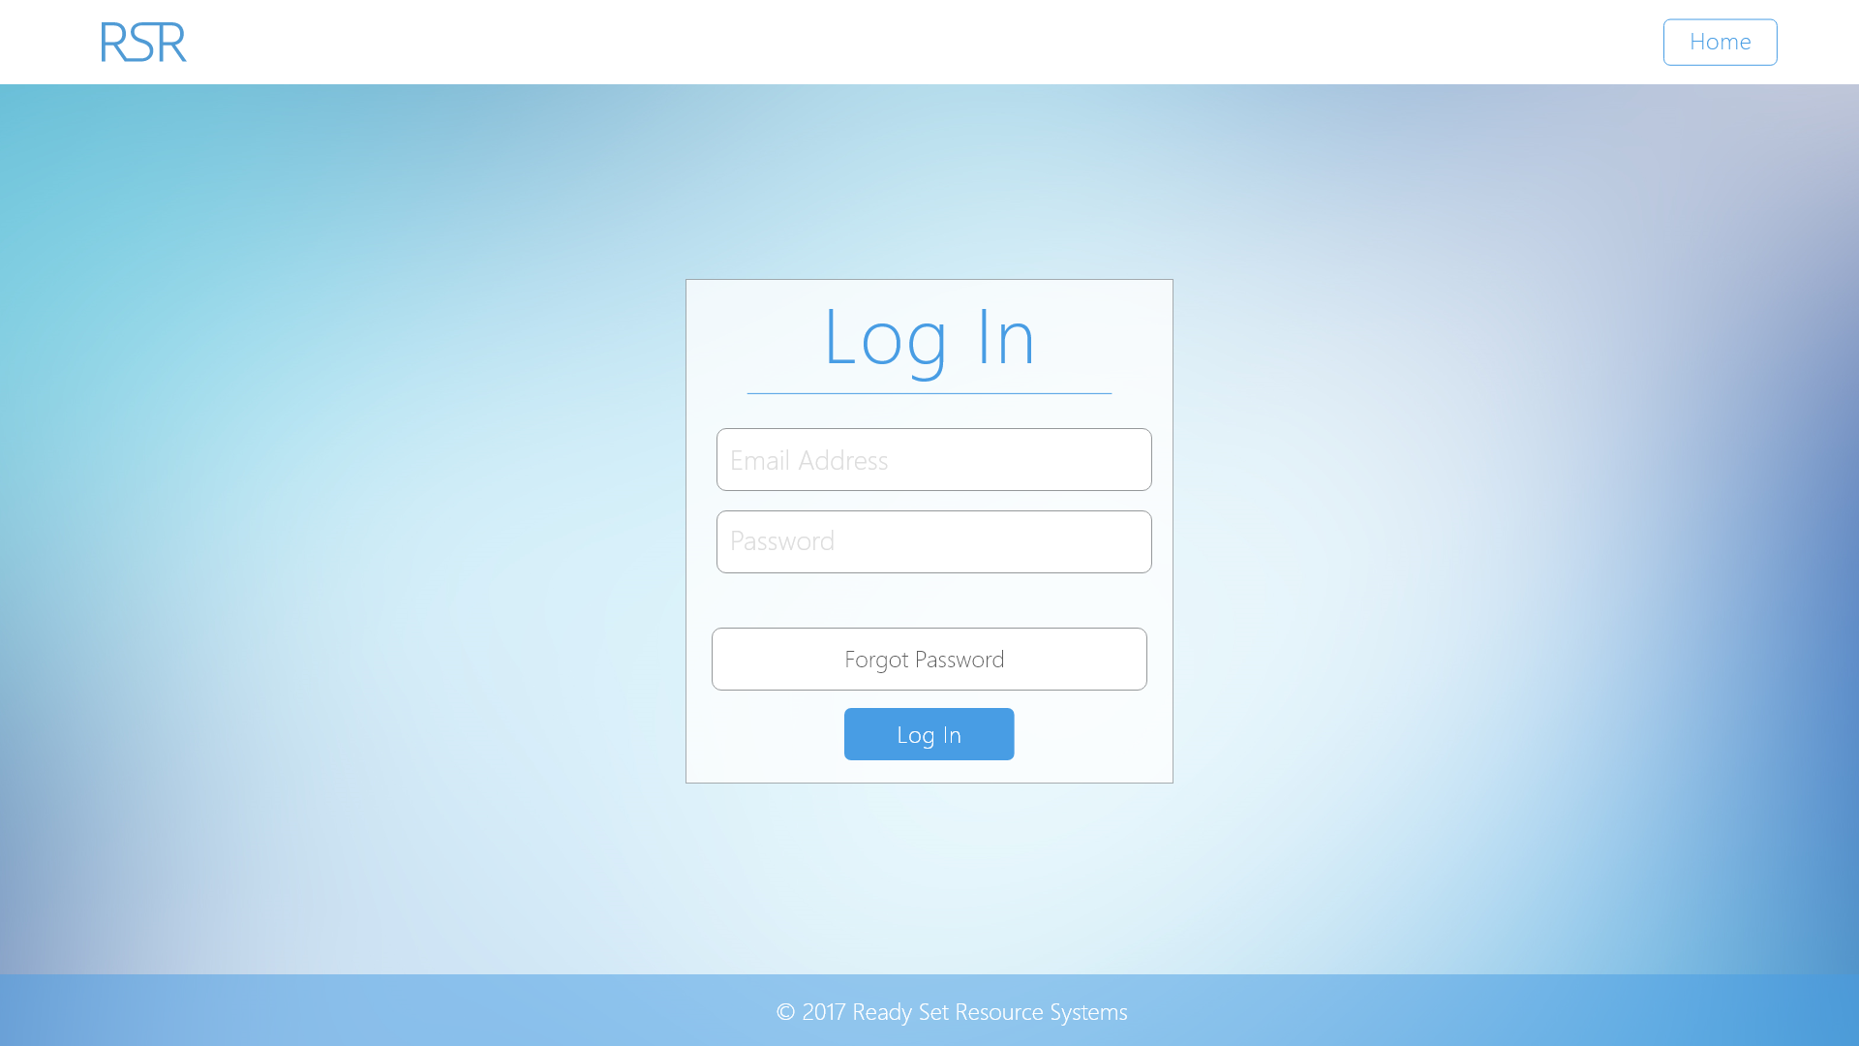

# 7.5 - Forgot Password

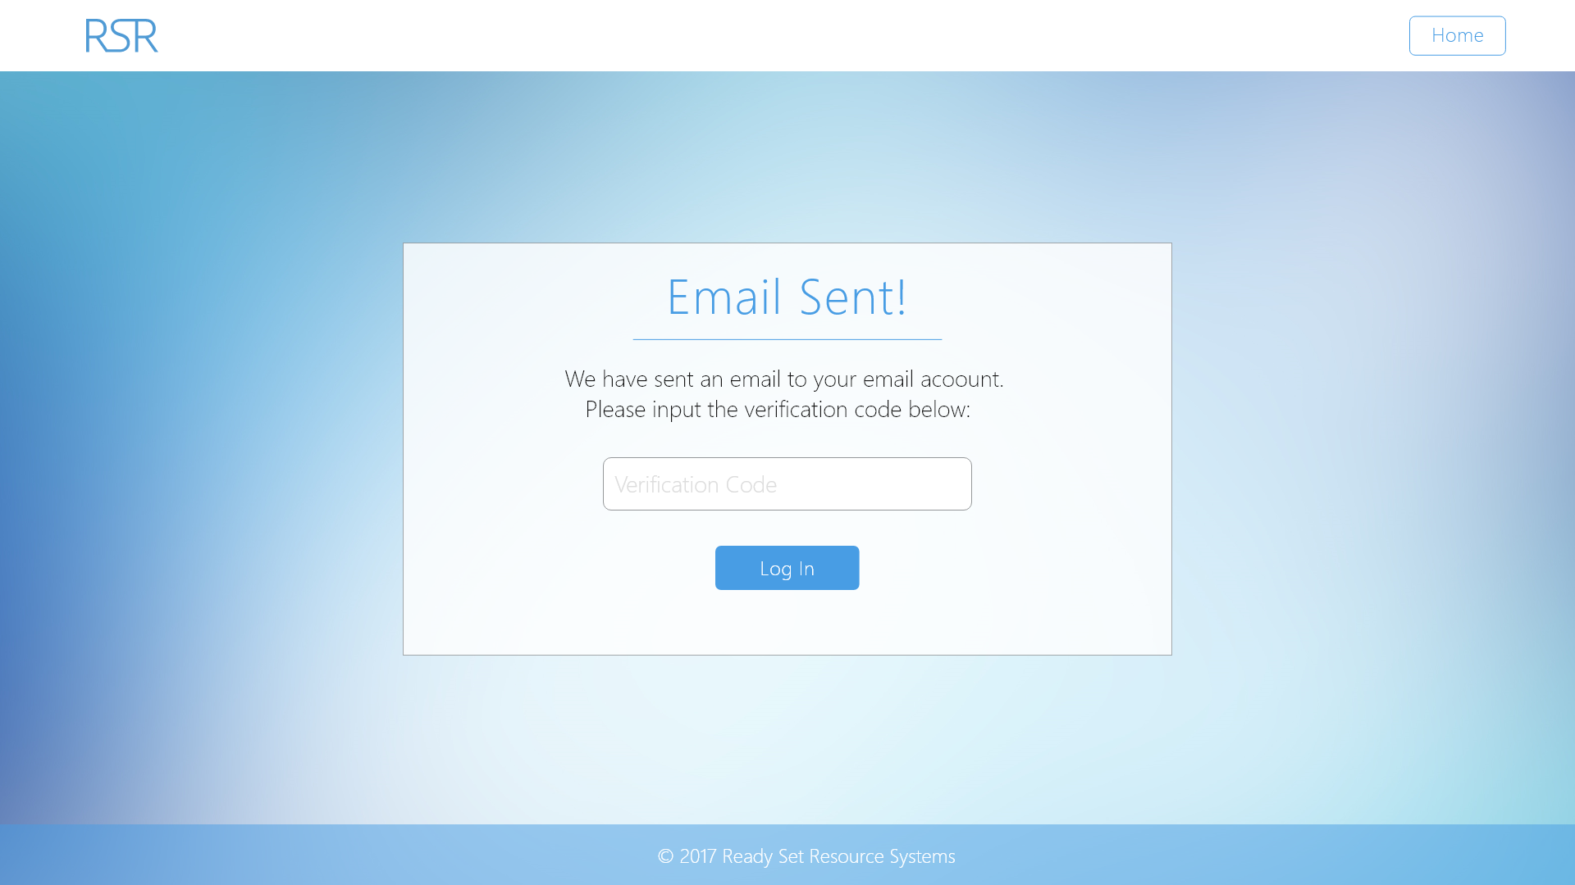

# 7.6 - Create New Password

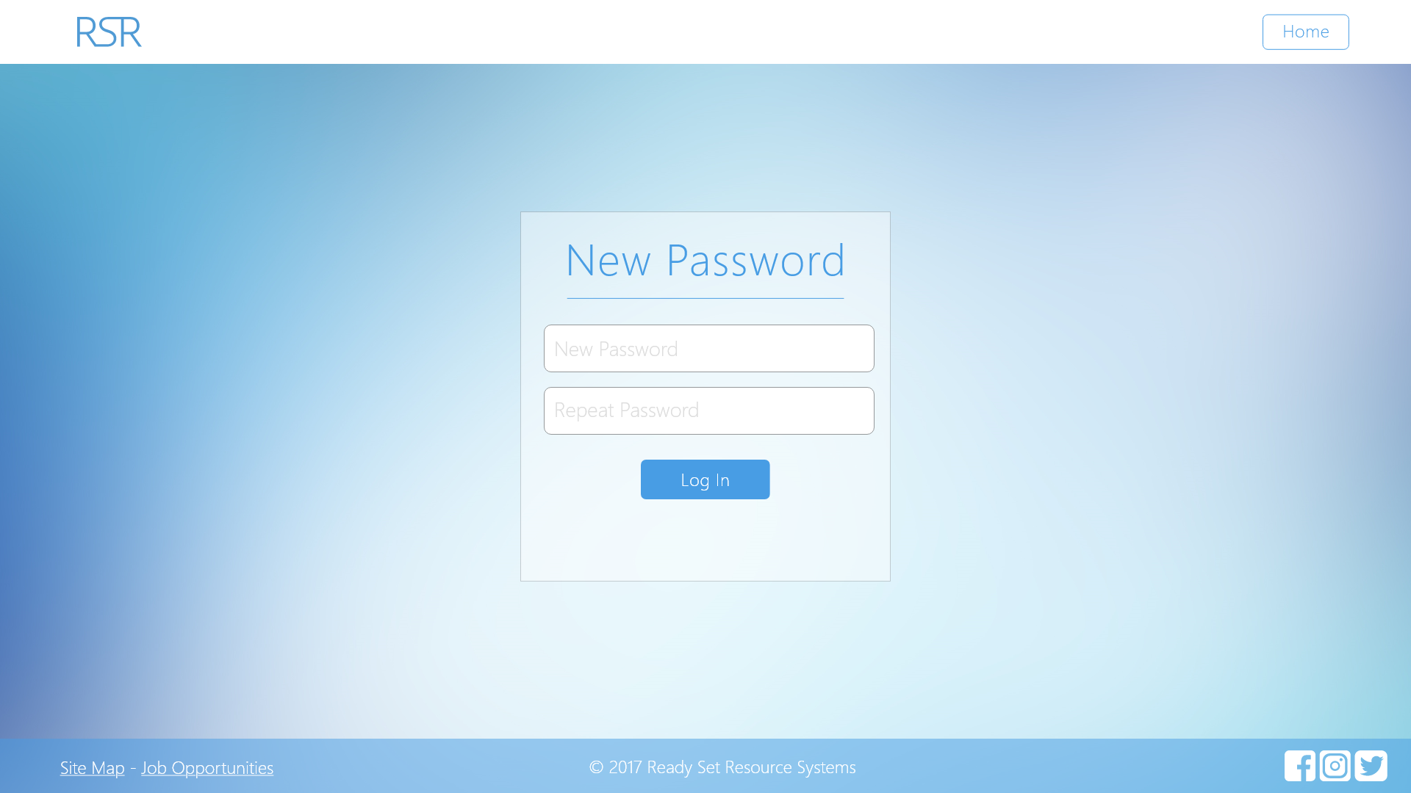

# 7.7 - Security Questions

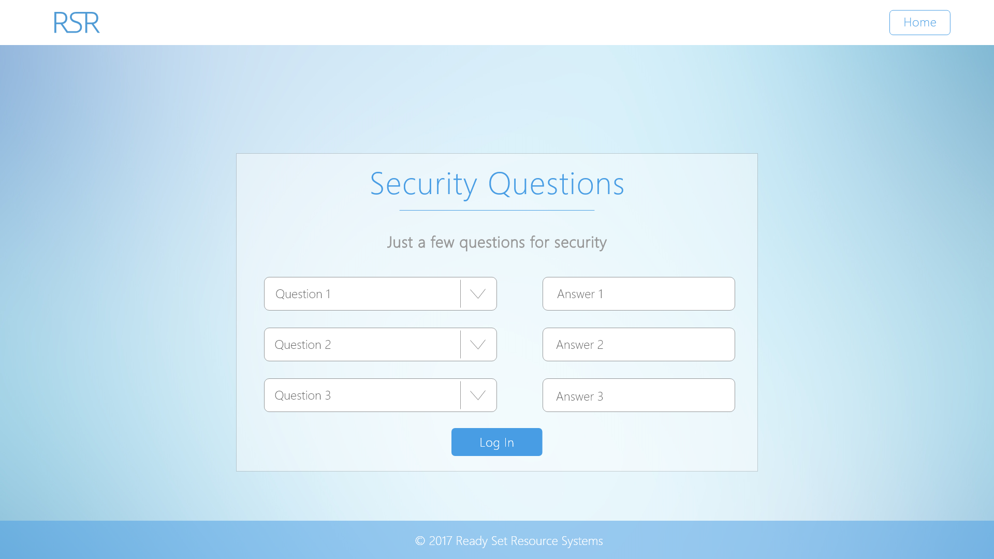

# 7.8 - Job Opportunities

# 7.9 - Credits

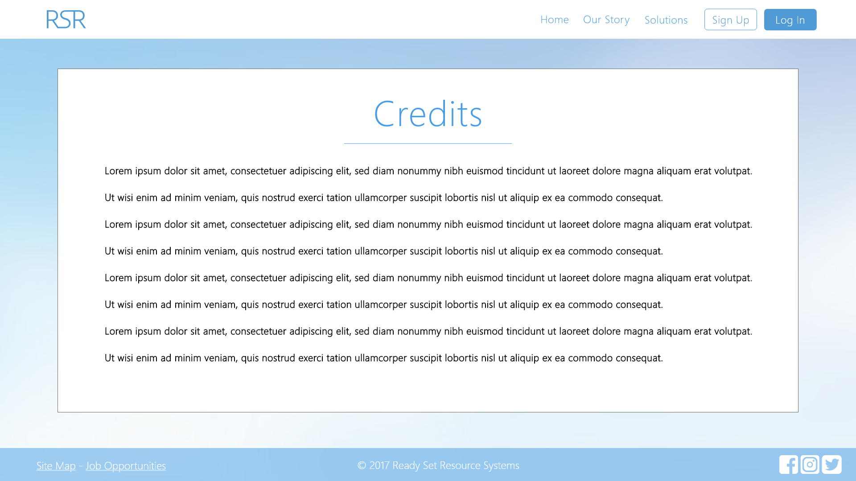

# 7.10 - Site Map

# 7.11 - Two-Factor Authentication

7.12 - UID /home/ Work Log

| Entry | Description | Person | Date | Mins Spent |
| --- | --- | --- | --- | --- |
| 1 | Formatted the document | Aidan Marshall | 7/10/17 | 12 |
| 2 | Copied the agreement from college website | Aidan Marshall | 7/10/17 | 23 |
| 3 | Completed the Bibliography | Aidan Marshall | 7/10/17 | 3 |
| 38 | | | | |